EXPERIMENT 17 : SUM OF INTEGERS FROM 1 TO N USING PROLOG
QUESTION
Write a Prolog program to calculate the sum of integers from 1 to N using recursion.
AIM
To write and execute a Prolog program to find the sum of integers from 1 to N using recursion.
PROCEDURE
- Start the program.
- Define the base case where N is 0 and the sum is 0.
- Define a recursive rule to calculate the sum of integers from 1 to N.
- Reduce N by 1 in each recursive call.
- Add N to the sum returned by the recursive call.
- Execute the program with a sample query.
- Display the result.
- Stop the program.
PROGRAM
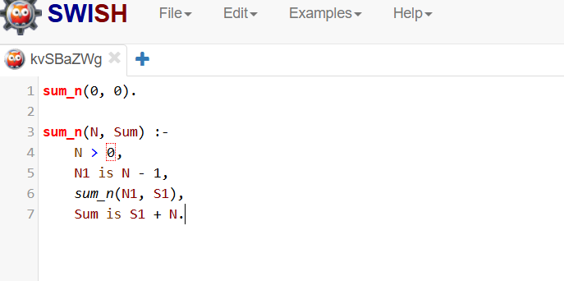

OUTPUT
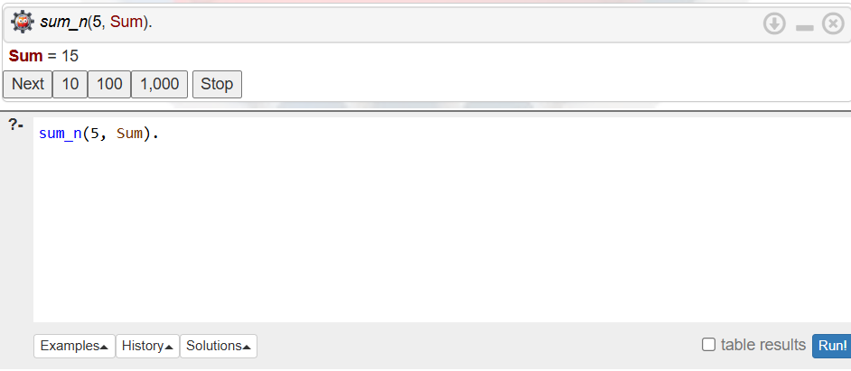

Sum = 15.
Calculation: 1 + 2 + 3 + 4 + 5 = 15
RESULT
Thus, the Prolog program to calculate the sum of integers from 1 to N using recursion was successfully executed.

